Siddhanta Shiromani
Grahaganit adhyaya Parvasambhadhikar
(Section III, Chapter 2 : Investigation into occurrence of an eclipse)

Verse No | Translations
1-2 | Multiply the number of years that have elapsed from the beginning of Kaliyuga by twelve and add to this the number of months elapsed from the beginning of the luni-solar year (from month Chaitra). If this result be x (number of months) then obtain another result y (no of lunar months) given by :  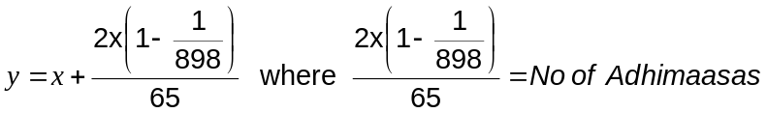  Hence the longitude of the sun with respect to a node (Sapaata-Surya) is given by  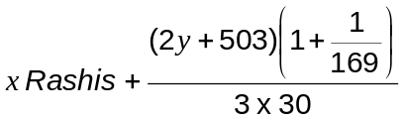  If this longitude is less than 14° then a lunar eclipse is likely to occur.
3-5 | Add 15° to the Sapaata Surya previously obtained and find out on which side the Sun lies, north or south. Compute the longitude of the sun from the number of days elapsed after the day on which the sun has left one zodiacal sign and entered another (Sankrtamana). Obtain the hour-angle (Nata) in naris of the Sun at the ending moment of New moon. Add or subtract one-fourth thereof in Rashis (1Rashi =30°) from the position of the sun according as the Sun is in the Western or Eastern Hemisphere. Then finding the declination of that point from the sum or difference of the declination and the latitude of that place (according as the Sun is in the Western or Eastern Hemisphere), obtain the zenith distance of the culminating point of the ecliptic. Taking that point roughly to be the point of ecliptic which is 90° behind the sun on the ecliptic (Vitribha), find one-sixth of the zenith distance. Taking the sum or difference of the result and the longitude of the sun with respect to the node(as obtained previously by adding 15° to his position at full moon) according as the Sun is in the Western or Eastern Hemisphere, if the result happens to fall short of 7°, then we could expect a solar eclipse.  If there be no eclipse at the current New Moon, then go on adding 1 Rashi 0° 40′15″ to the longitude of the sun with respect to the node (which will be his longitude for the moment of the next moon) and repeating the procedure indicated, the occurrence of an eclipse or otherwise could be known. If occurrence be indicated then compute the actual positions of Sun, moon and Rahu and following the procedure to be indicated in Chapter on solar eclipses, the moment of the occurrence of the eclipse and other relevant details could be computed.
Hence ends the chapter named Parvasambhadikar
of Grahaganita part of Siddhanta Shiromani

